**Game Design Document**

**High Concept:**

The concept of this game is a top-down space shooter in which you must kill enemies, avoid, and shoot asteroids and defeat various bosses. The game is called Space Adventures. This game is based off space invaders a popular top-down space shooter.

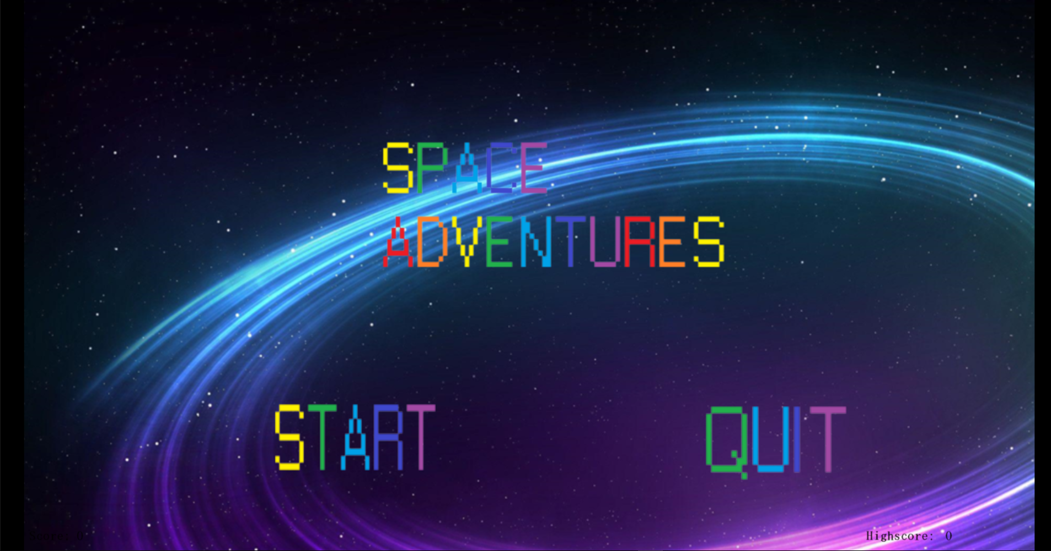

**Genre:**

The genre of this game as I said above is a top-down space shooter like space invaders. Except in comparison mine is a very basic version of this game. It was quite a popular genre a while ago with a lot of arcade games being top-down space shooters.

**Gameplay:**

To play this game you will use the W, A, S, D, E, and Space Keys. In this game you fly around killing and defeating enemies in an alien war, where you have several bosses to pass and defeat to progress. As you power through each level the enemies always stay the same but each boss is different getting harder and taking longer to defeat as you go throughout the game. In the final level there are no enemy ships you have to fight instead its just one big boss you have to compete with and defeat. As it is a top-down game it appears that you are watching from above like a birds eye view. Lastly, you must also try and avoid asteroids and remove them from your way either by shooting them or crashing into them but remember if you crash into them you will lose health.

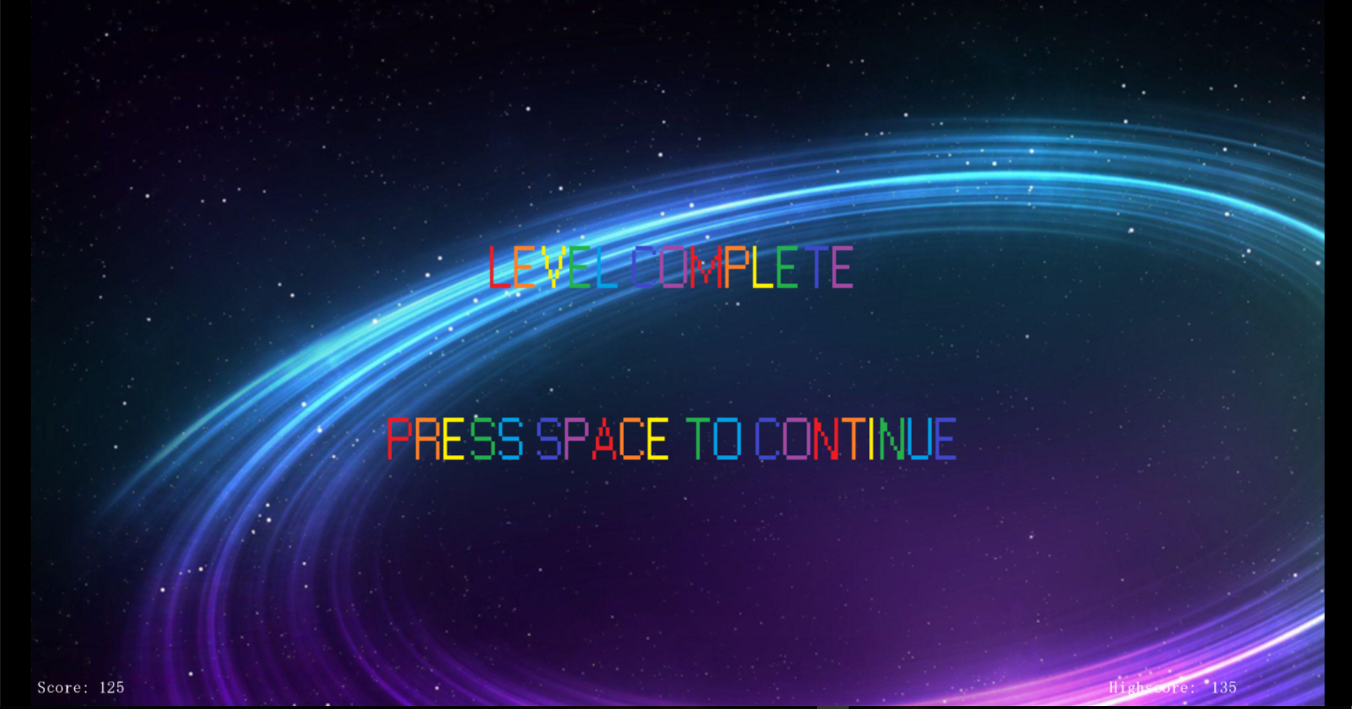

**Features:**

Some of the main features included in my game are:

* **The main spaceship**, this is the spaceship you fly around and use to kill enemies and bosses. With this spaceship you have two types of ammo, your main ammo, and the special ammo which you can use if you pick it up throughout the game. It also has very basic movement meaning you can go up, right, left, and down but you cannot move in circles.
* **The enemy ships**, these enemy ships spawn in using a timeline. Each one is set to spawn in after a certain number of seconds and your job is to hit them and destroy them. Each of the basic enemies have 30 health making the game easier meaning after three shots they are destroyed. But be careful if you hit them, you will take damage!
* **The bosses**, in each level there is a new boss to defeat. Each boss comes with a different health level and as each level progresses the bosses take longer to kill. Be careful though if you run into the boss you will die. When the boss is hit by normal ammo it takes ten damage but when it is hit with special ammo it takes twenty damage. Like the enemies the bosses spawn in using the timeline but they do not appear until all the other timeline events have been done. Therefore, he spawns in at the end of leach level.
* **The levels**, unlike the last game I made each new level of the game is the same all that changes is the background and while yes this is a downfall to my game and each of the same events are replayed through each level each level tends to have a different boss making up for the fact that each level is quite similar.

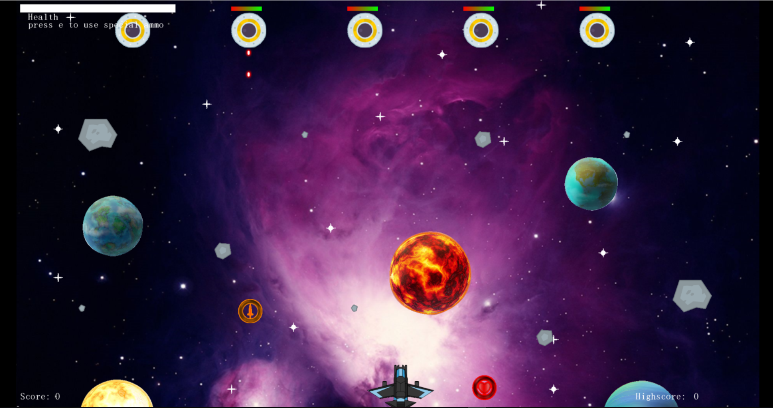

**Setting:**

To make my game world I used various planets, asteroids, and stars to make it appear that you are floating through space. On top of that I have the enemies set so that the move across and down the screen to make it seem like you are in a war with alien ships and that they are either flying towards you or away from you. Unlike the enemies you can control where your ship moves around the screen which makes it unique because it looks like your either flying toward the enemy or trying to get away.

**Target Market:**

The target market for this game is anyone aged six and up. The reason I said this age group as it is not a hard game to play. The game would be made and promoted to the demographic who enjoy top-down shooters and arcade games such as space invaders as its quite a similar game.

**Competitive Analysis:**

For games of this genre there has many games released in the top-down genre. Some of the most popular games are:

* Invalians
* Shooting Ships Mix
* Bit Blaster XL
* The Core Message

The games I have mentioned above are the most popular top-down shooters according to steam, And I feel if my game was to be released alongside them while not doing as good would still bring in some revenue and I think it would be played.

**Document Summary:**

Overall, this would be quite a simple and relaxing game to play as there are no hard bosses you must defeat and it’s a basic version of Space Invaders. I also feel it would be a very good game to play as it is a small game with a simple design and a basic aim. Lastly, I feel this is a game that you would only play once therefore if it was released onto the market, it would be a cheap game to by ranging between €1- and €2 and because its quite small and basic it wouldn’t be a hard game to grind therefore making it great for young children.

